# Lab 7

In this part, students will develop a mobile application which is more than one page.

Here are the screen captures of the application:

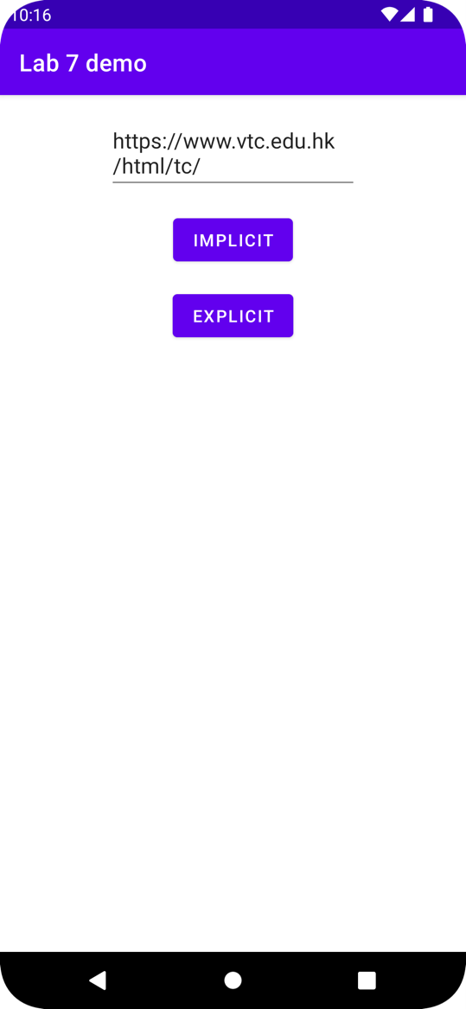

Step 1:

In Android Studio, create a new project named Lab 6 with following project setting:

* Choose your project : **Empty Activity**
* Application Name : **Lab 7**
* Project location : use the default setting
* Language : **Java**
* Minimum API level: **API 21: Android 5.0 (Lollipop)**
* Click **Finish**

Step 2:  
Open strings.xml and insert the following code:

<resources>  
 <string name="app_name">Lab 7</string>  
 <string name="url">https://www.vtc.edu.hk/html/tc/</string>  
 <string name="implicit">implicit</string>  
 <string name="explicit">explicit</string>  
</resources>

Step 3:  
Open activity_main.xml and insert the following code:

*<?*xml version="1.0" encoding="utf-8"*?>*<androidx.constraintlayout.widget.ConstraintLayout xmlns:android="http://schemas.android.com/apk/res/android"  
 xmlns:app="http://schemas.android.com/apk/res-auto"  
 xmlns:tools="http://schemas.android.com/tools"  
 android:layout_width="match_parent"  
 android:layout_height="match_parent"  
 tools:context=".MainActivity">

<EditText  
 android:id="@+id/editText"  
 android:layout_width="wrap_content"  
 android:layout_height="wrap_content"  
 android:layout_marginStart="16dp"  
 android:layout_marginTop="16dp"  
 android:layout_marginEnd="16dp"  
 android:ems="10"  
 android:text="@string/url"  
 app:layout_constraintEnd_toEndOf="parent"  
 app:layout_constraintStart_toStartOf="parent"  
 app:layout_constraintTop_toTopOf="parent" />  
  
<Button  
 android:id="@+id/implicit"  
 android:layout_width="wrap_content"  
 android:layout_height="wrap_content"  
 android:layout_marginStart="16dp"  
 android:layout_marginTop="16dp"  
 android:layout_marginEnd="16dp"  
 android:text="@string/implicit"  
 android:onClick="implicitClick"  
 app:layout_constraintEnd_toEndOf="parent"  
 app:layout_constraintStart_toStartOf="parent"  
 app:layout_constraintTop_toBottomOf="@+id/editText" />

<Button  
 android:id="@+id/explicit"  
 android:layout_width="wrap_content"  
 android:layout_height="wrap_content"  
 android:layout_marginStart="16dp"  
 android:layout_marginTop="16dp"  
 android:layout_marginEnd="16dp"  
 android:text="@string/explicit"  
 android:onClick="explicitClick"  
 app:layout_constraintEnd_toEndOf="parent"  
 app:layout_constraintStart_toStartOf="parent"  
 app:layout_constraintTop_toBottomOf="@+id/implicit" />  
</androidx.constraintlayout.widget.ConstraintLayout>

Step 4:

Move to MainActivity.java and insert the following code to define the layout and method that we need to use.

public class MainActivity extends AppCompatActivity {  
  
 EditText editText;  
 String s; *//used for storing the text from edittext*  
 @Override  
 protected void onCreate(Bundle savedInstanceState) {  
 super.onCreate(savedInstanceState);  
 setContentView(R.layout.*activity_main*);  
 editText=findViewById(R.id.*editText*);  
 s=editText.getText().toString();  
 }  
  
 public void implicitClick(View v){  
   
 }  
  
 public void explicitClick(View v){  
   
 }  
}

Step 5:

Go to AndroidManifest.xml and add the following code outside the Application layer.

<uses-permission android:name="android.permission.INTERNET" />

Step 6:

To pass the message or action to another application or activity, Intent will be used. For the implicit intent, it means it will pass the data to the related application. Replace the following code and run the app, you will see the app will change Chrome when you click “IMPLICIT”.

public void implicitClick(View v){  
 Uri uri= Uri.*parse*(s);  
 Intent intent=new Intent(Intent.*ACTION_VIEW*,uri);  
 startActivity(intent);  
}

Step 7:

We need to pass the data to another activity, so we need to use putExtra() to do, it needs to fill in a key and the content that we need to pass. Replace the following code for explicit intent. However, it will occur an error. Why?

public void explicitClick(View v){  
 *//Intent intent=new Intent(MainActivity.this, SecondActivity.class);* Intent intent=new Intent(getApplicationContext(), SecondActivity.class);  
 intent.putExtra("message",s);  
 startActivity(intent);  
}

Since we have not created the SecondActivity yet~

Step 8:

Right click com.example.lab6 -> New -> Activity->Empty Activity, type “SecondActivity”, then press Enter.

Step 9:

Open activity_second.xml and replace the following code:

*<?*xml version="1.0" encoding="utf-8"*?>*<androidx.constraintlayout.widget.ConstraintLayout xmlns:android="http://schemas.android.com/apk/res/android"  
 xmlns:app="http://schemas.android.com/apk/res-auto"  
 xmlns:tools="http://schemas.android.com/tools"  
 android:layout_width="match_parent"  
 android:layout_height="match_parent"  
 tools:context=".SecondActivity">  
  
 <TextView  
 android:id="@+id/result"  
 android:layout_width="wrap_content"  
 android:layout_height="wrap_content"  
 android:text="TextView"  
 app:layout_constraintBottom_toBottomOf="parent"  
 app:layout_constraintEnd_toEndOf="parent"  
 app:layout_constraintStart_toStartOf="parent"  
 app:layout_constraintTop_toTopOf="parent" />  
</androidx.constraintlayout.widget.ConstraintLayout>

Step 10:

Since we need to catch the data that passed from MainActivity.java (Step 7), we need to use getIntent() for catching.

public class SecondActivity extends AppCompatActivity {  
  
 TextView result;  
 @Override  
 protected void onCreate(Bundle savedInstanceState) {  
 super.onCreate(savedInstanceState);  
 setContentView(R.layout.*activity_second*);  
 result=findViewById(R.id.*result*);  
 Intent intent= getIntent();  
 String ss=intent.getStringExtra("message");  
 result.setText(ss);  
 }  
}